Unit 1: Introduction

Foundation of Algorithm Analysis
Algorithm and its properties
An algorithm is a finite set of computational instructions, each instruction can be executed in finite time, to perform computation or problem solving by giving some value, or set of values as input to produce some value, or set of values as output. Algorithms are not dependent on a particular machine, programming language or compilers i.e., algorithms run in same manner everywhere. So, the algorithm is a mathematical object where the algorithms are assumed to be run under machine with unlimited capacity.

Examples of problems
• we are given two numbers; how do we find the Greatest Common Divisor.
• Given an array of numbers, how do we sort them?
We need algorithms to understand the basic concepts of the Computer Science,
programming. Where the computations are done and to understand the input
output relation of the problem, we must be able to understand the steps involved
in getting output(s) from the given input(s).

We need designing concepts of the algorithms because if we only study the
algorithms then we are bound to those algorithms and selection among the
available algorithms. However, if you have knowledge about design then we can
attempt to improve the performance using different design principles.

The analysis of the algorithms gives a good insight of the algorithms under study.
Analysis of algorithms tries to answer few questions like; is the algorithm correct?
i.e., the Algorithm generates the required result or not? does the algorithm
terminate for all the inputs under problem domain? The other issues of analysis

are efficiency, optimality, etc. So knowing the different aspects of different algorithms on the similar problem domain we can choose the better algorithm for our need. This can be done by knowing the resources needed for the algorithm for its execution. Two most important resources are the time and the space. Both of the resources are measures in terms of complexity for time instead of absolute time we consider growth

Algorithms Properties
Input(s)/output(s): There must be some inputs from the standard set of inputs and an algorithm’s execution must produce outputs(s).
Definiteness: Each step must be clear and unambiguous.
Finiteness: Algorithms must terminate after finite time or steps.
Correctness: Correct set of output values must be produced from the each set of inputs.
Effectiveness: Each step must be carried out in finite time.
Here we deal with correctness and finiteness.

Algorithm Specification:
- Pseudocode Conventions
Pseudocode is a high-level description of a computer program or algorithm that uses a mix of natural language and simple programming constructs to outline the logic of the solution.
- It is not a programming language with specific syntax but serves as a bridge between human understanding and actual code implementation.
- Pseudocode conventions help standardize the way pseudocode is written, making it more readable and universally understood. Here's an introduction to some common pseudocode conventions.

- Readability and Consistency
- Use consistent indentation to indicate control structures (e.g., loops and conditionals).
- Be mindful of whitespace and line breaks to improve readability.
- Choose a clear and consistent naming convention for variables and functions.
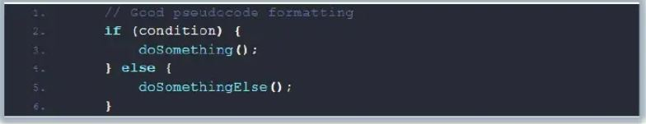
- Use of keywords:
- Use consistent indentation to indicate control structures (e.g., loops and conditionals).
- Be mindful of whitespace and line breaks to improve readability.
- Choose a clear and consistent naming convention for variables and functions.
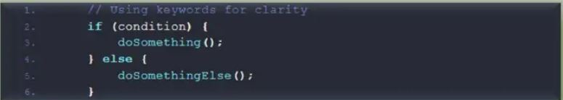

- Comments and Annotations
- Include comments or annotations to explain complex or non-obvious parts of the pseudocode.
- Comments should provide insight into the logic and purpose of the code.

- Modularization:
- User clear and meaningful function names to describe their purpose.
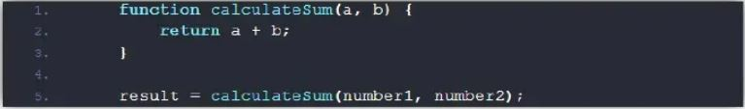

- Use of Control Structures:
- Utilize standard control structures such as “if-else”, “while”, and “for” loops to represent conditional and iterative logic.
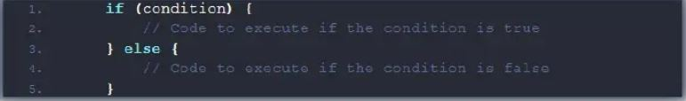

- Data Types:
- Pseudocode often abstracts data types, but you can use descriptive terms like “integer”, “string”, or “list” when necessary.
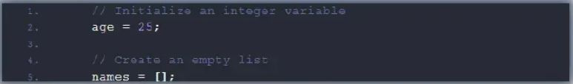
- Error Handling:
- If your algorithm involves error handling, use pseudocode to outline how errors are detached and handled.
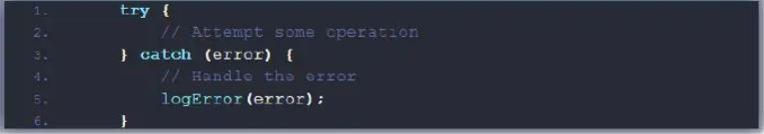
- Iteration and Looping:
- Clearly define the start and end conditions for loops.
- Indicate how loop variables are updated within the loop.
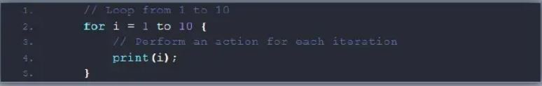

Recursive Algorithm:
Recursion is a technique used in computer science to solve big problems by breaking them into smaller, similar problems. The process in which a function calls itself directly or indirectly is called recursion and the corresponding function is called a recursive function. Using a recursive algorithm, certain problems can be solved quite easily.

Recurrence Relations

A recurrence relation is a mathematical expression that defines a sequence in terms of its previous terms. In the context of algorithmic analysis, it is often used to model the time complexity of recursive algorithms.
General form of a Recurrence Relation:

an=f(an−1,an−2,....,an−k)
where f is a function that defines the relationship between the current term and the previous terms

Common Examples of Recurrence Relations:
- Fibonacci Sequence: F(n) = F(n-1) + F(n-2)
- Merge Sort: T(n) = 2*T(n/2) +O(n)
- Binary Search: T(n) = T(n/2) +1

Ways to Solve Recurrence Relations:

1. Substitution Method
- Recurrence Tree Method

- Master Method

- Recursion Tree Method to Solve Recurrences

The recursion tree method is used to analyze the time complexity of recursive algorithms by visually representing the recurrence as a tree. Each node of the tree represents the work done in a single recursive call, and each level represents one stage of the recursion.
Below are the steps used to find time complexity using recursion tree method.
- Draw a recursive tree for given recurrence relation
- Calculate the cost at each level and count the total no of levels in the recursion tree.
- Sum up the cost of all the levels in the recursive tree

See class note.

Time and Space Complexity
Best, Worst and Average case
Best case complexity gives lower bound on the running time of the
algorithm for any instance of input(s). This indicates that the algorithm
can never have lower running time than best case for particular class of problems.

Worst case complexity gives upper bound on the running time of the
algorithm for all the instances of the input(s). This ensures that no input
can overcome the running time limit posed by worst case complexity.

Average case complexity gives average number of steps required on any
instance of the input(s).

See old note for Asymptotic Notation. “

Randomized Algorithms:
A Randomized Algorithm is an algorithm that uses random numbers to make decisions during its execution. Unlike deterministic algorithms, which follow a fixed path for a given input, randomized algorithms can behave differently across different runs on the same input.
An algorithm that uses random numbers to decide what to do next anywhere in its logic is called a Randomized Algorithm. For example, in Randomized Quick Sort, we use a random number to pick the next pivot (or we randomly shuffle the array).

